Cover Page


UW004DS - Certificate in Junior Python Data Analyst
Genshin Impact Business Proposal

Ha Noi V.C.
(Eric, Kenneth, Justin, Manning)

Content Page
Content
1. Introduction Page
1.1 Company Background 1
1.2 Proposal Objective 1
1.3 Data Preparation 1
1.3.1 Exploring the revenue (DF1) dataset 2
1.3.2 Use a “float” data type for “Revenue” Column 2
1.3.3 Merging Reruns of the Same Character into One Row 3
1.3.4 Replacing NaN revenue numbers by zeroes 3
1.3.5 Exploring the character feature (DF2) dataset and Votes(DF3) dataset 4

2.Data Analysis
2.1 Intertwining and Divergence of Character Popularity and Commercial Revenue
2.1.1 Dimensions of Correlation Between Popularity and Revenue 7
2.1.2 Factors of Divergence and Exceptions Between Popularity and Revenue 10
2.1.3 Summary of Impact of Popularity on Revenue 10

2.2 Impact of Abilities on Daily Revenue
2.2.1 Definition 11
2.2.2 Correlation between Stats and Revenue 12
2.2.3 Revenue Distribution across Skill Types 14
2.2.4 Summary of Impact of Abilities on Daily Revenue 15

2.3 Revenue Analysis
2.3.1 Revenue timeline by Event Type 16
2.3.2 All Characters Revenue 17
2.3.3 All Characters Total Revenue 18
2.3.4 Key Performer Business Model Insights 19
2.3.5 Heatmap Analysis 20
2.3.6 Summary of Impact on Revenue 21

3. Conclusion & Suggestion 22

4. Appendix 23

1. Introduction
1. Introduction

1.1 Company Background
We are Ha Noi VC, we are here to recommend strategies and recommendations on how our client, Genshin Impact, to improve its revenue in the video game market. Genshin Impact was developed back in 2020. It is a role-playing video game developed in China. The game features an anime-style open-world environment and an action-based battle system. It has been very successful in content management and good at improving customer loyalty.

The main income stream of this game is to release very well designed playable characters for players to draw in a Gacha system. The higher amount of cash paid by the players will result in a higher chance for them to obtain the reward.

1.2 Proposal Objective
In our project, we are trying to discover from Genshin Impact’s dataset on what the game product team can do to increase revenue in their future character design, so as to achieve continuous monetization from current and potential players.

1.3 Data Preparation
We found three datasets of Genshin Impact’s game data and revenue figures from the Kaggle data mining website. We will mainly talk about how our team validated and preprocessed the datasets and what we have found during data preparation.

1.3.1 Exploring the revenue (DF1) dataset
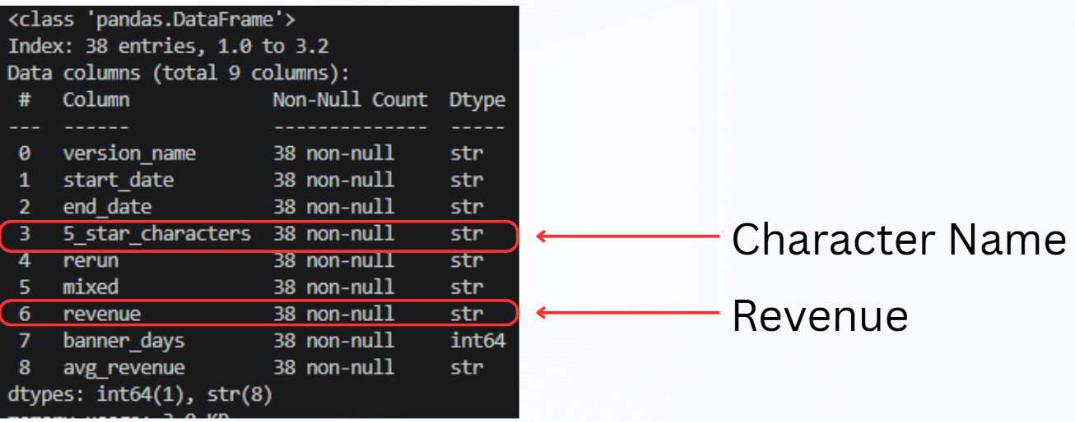The first set of data, we denoted it as dataframe1. It is from Genshin Character Revenue (By Banner) csv. It has columns such as version name, character name, and the respective revenue figures of each character release.

Notice that there are some special columns, such as “rerun” and “mixed”. “Rerun” column represents sales of old but popular playable characters. “Mixed” column represents combining two or even three playable characters in the same promotion period. Finally, we have the column “Banner days”, which describes how long the character was allowed to be purchased.

1.3.2 Use a “float” data type for “Revenue” Column
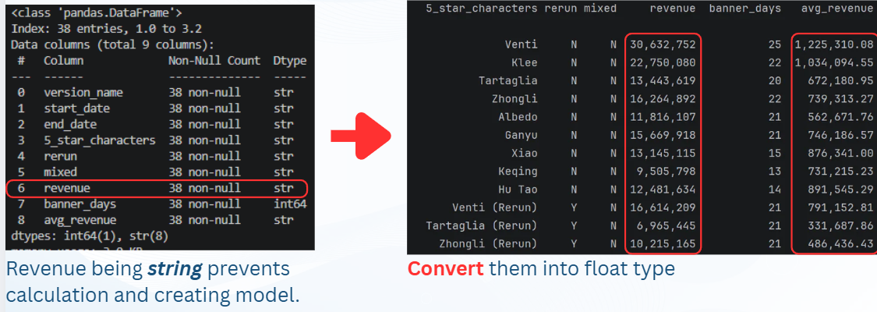In dataframe 1, there are some major issues in this dataset. First of all, the revenue amounts are expressed in string data type. This is not a good data type, as these amounts are important figures which may require numerical methods or may be used in regressions. Therefore, we use simple ways in Python to convert them from strings back to float data types.
1.3.3 Merging Reruns of the Same Character into One Row
Each playable character may have more than one row in this dataset. Each row represents the individual release, and may even have the revenue figures messed up with other characters. Our objective in this project is to find out the relationship between each playable character and the revenue as a whole. More columns are created in this dataset so we can combine reruns of each character into the same row.
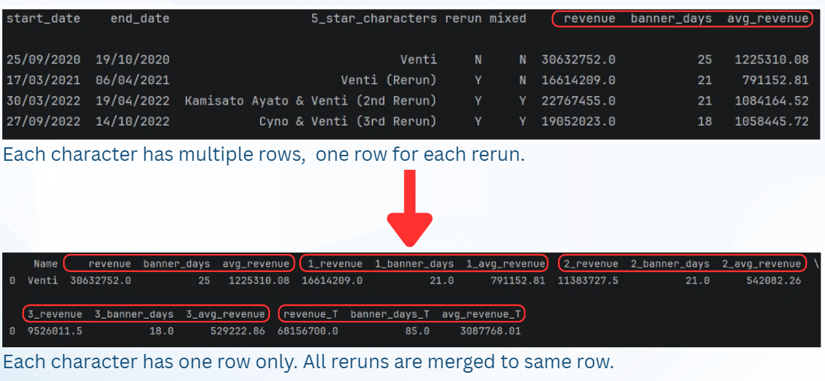
As shown above, each rerun revenue will be represented by 1_revenue, 2_revenue, 3_revenue where the number denotes the number of reruns. Fields such as revenue_T, avg_revenue_T are built by summing up the revenue numbers.

1.3.4 Replacing NaN revenue numbers by zeroes
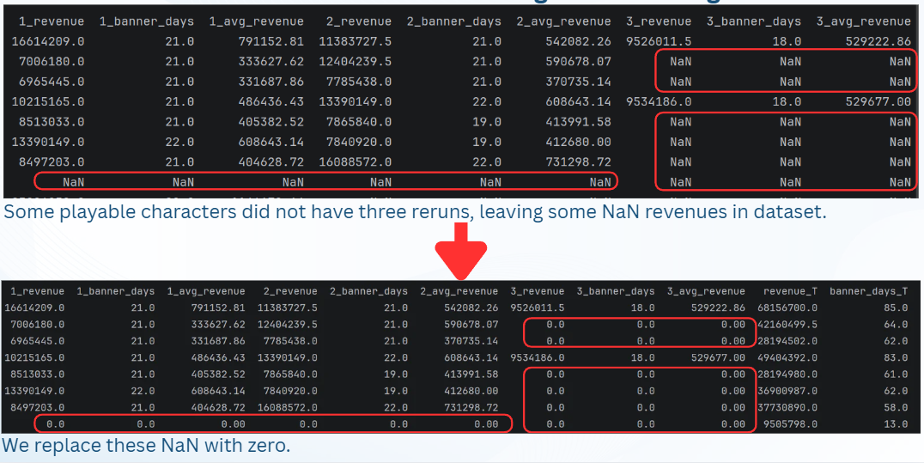After finishing the merge, we expected some revenue figures may have missing values. It is natural, because not all of the playable characters have reruns. There are also characters who have less than three reruns as well. We can simply replace the missing values (NaN) by number zero without affecting the actual information of the dataset.
1.3.5 Exploring the character feature (DF2) dataset and Votes(DF3) dataset
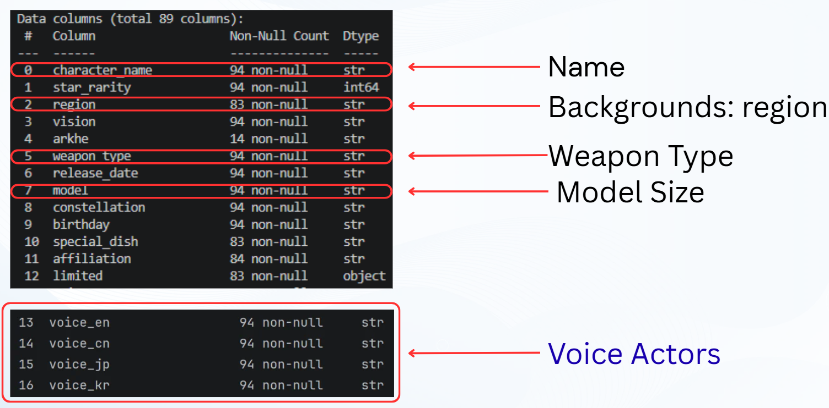Dataframe 2 includes a huge amount of backgrounds and statistics of Genshin characters. We can know where their birthdays are, which region they come from, the size of their bodies, their corresponding voice actors, etc. We can easily make some pie charts to let us dive into the relationship between revenue and characters’ features.

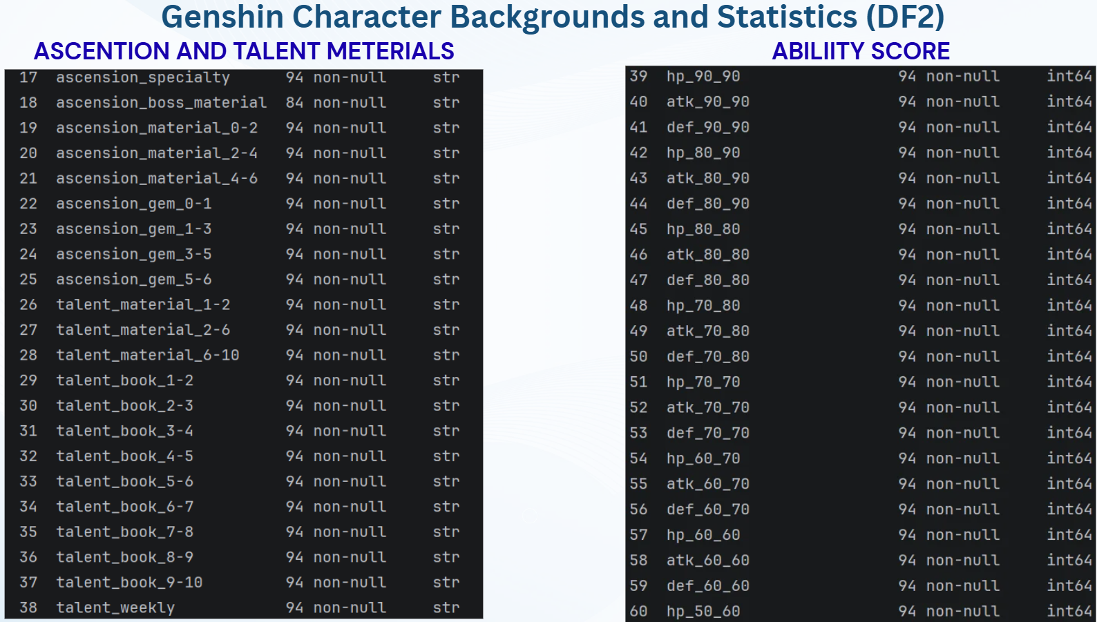
Furthermore, we have many columns which are about how they can become stronger by collecting materials for ascensions or talents. We also notice there are ability scores statistics for each character. Such fields might be useful for us to understand whether some of these ability scores attract consumers to buy the character.
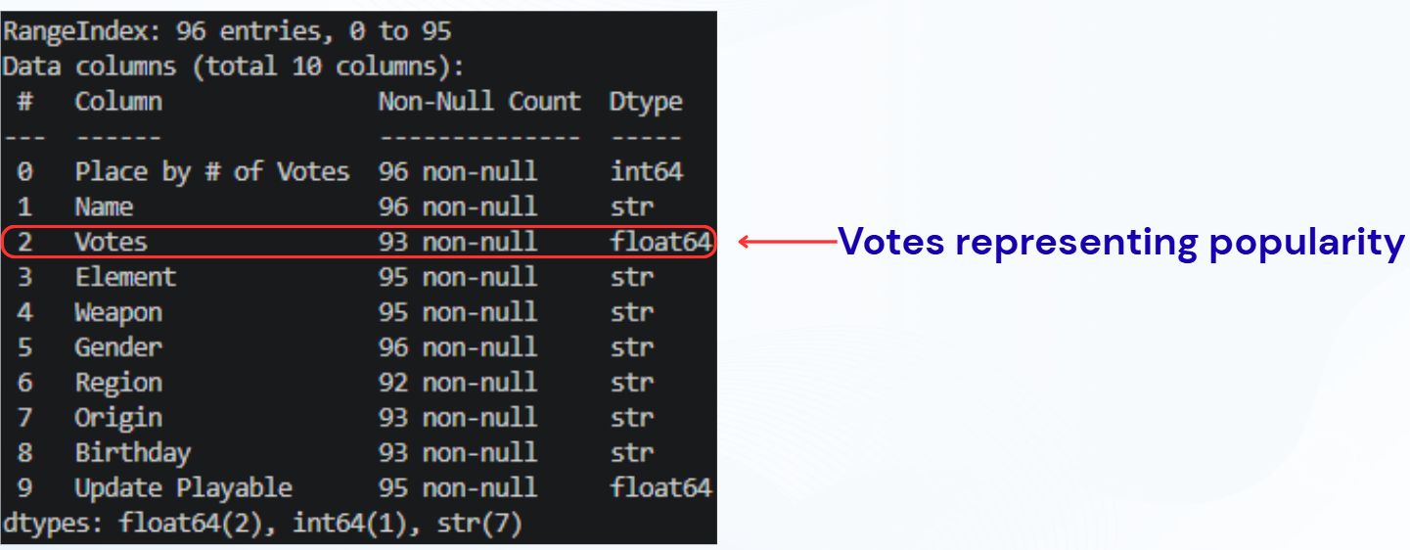
In dataframe 3, we have the votes made by players in the year end of 2024, which tell us more about how popular each playable character is. Such figures allow us to understand the relationship between popularity and revenue.

2. Data Analysis
2. Data Analysis

2.1 Intertwining and Divergence of Character Popularity and Commercial Revenue
In game character operations and commercialization strategies, the relationship between "popularity" (player votes) and "revenue" (financial gain) remains a core focus. Overall, data indicates that character heat and monetization capability are positively correlated—characters with higher popularity generally bring in higher revenue. However, a deeper look into regional dynamics, character design, weapon types, and operational strategies reveals frequent discrepancies between the two (reflected in low $R^{2}$ values). This demonstrates that popularity is not the sole determinant of revenue.
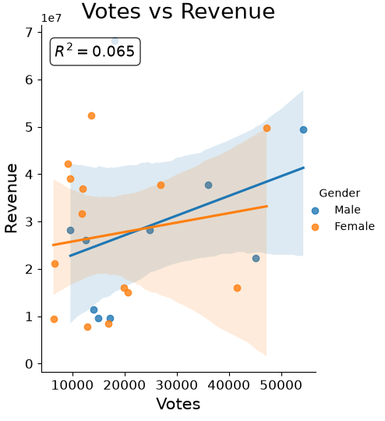

2.1.1 Dimensions of Correlation Between Popularity and Revenue
Under standard conditions, popularity and revenue exhibit strong alignment:
- Regional and Cultural Resonance:
Characters from specific regions like Inazuma (e.g., Raiden Shogun) achieve both high popularity and revenue peaks. This proves that compelling regional storylines and cultural packaging effectively drive both engagement and spending.
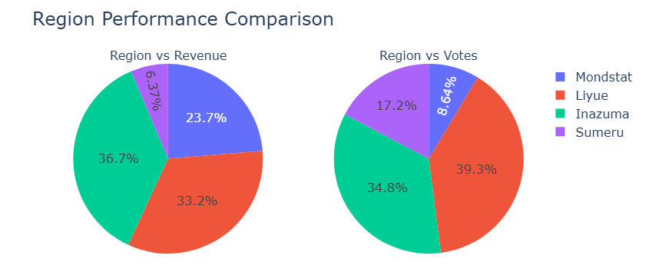
Popular Weapon and Form Combinations:
Polearms combined with Electro or Geo elements demonstrate high popularity and conversion rates across both male and female characters. Additionally, "Tall" character models (e.g., Zhongli, Raiden Shogun) serve as a key visual element attracting both votes and purchases.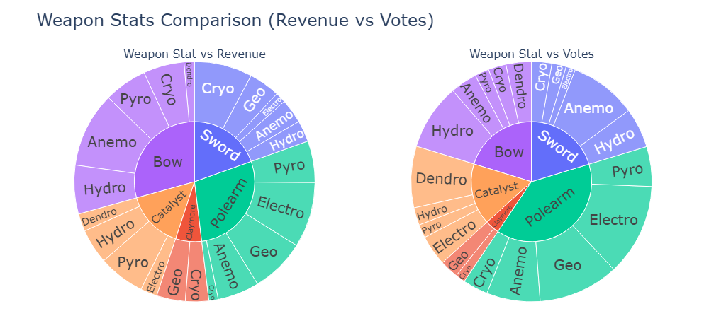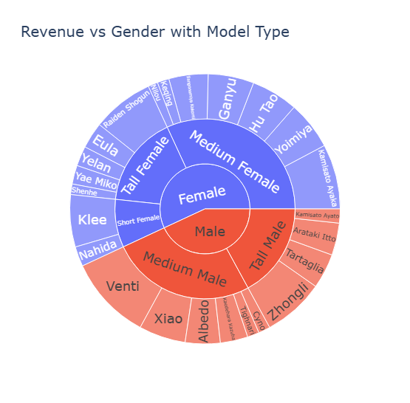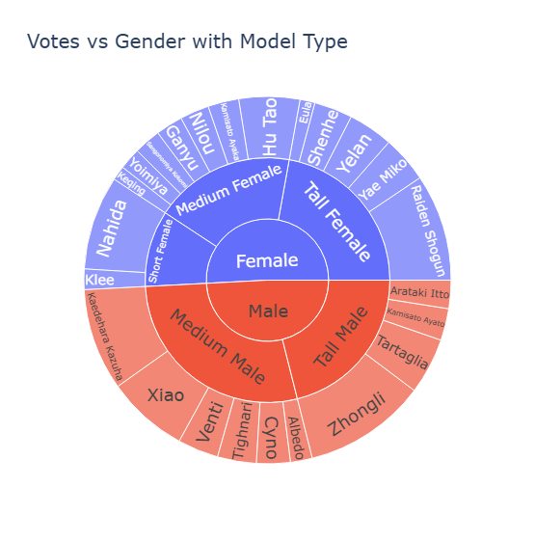
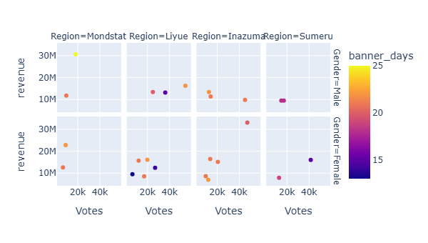

- Banner Duration:
Data shows that the length of a banner period (e.g., Zhongli’s 83 days, Venti’s 85 days) correlates positively with peak votes and revenue. Longer operational windows allow sufficient time to convert popularity into actual sales.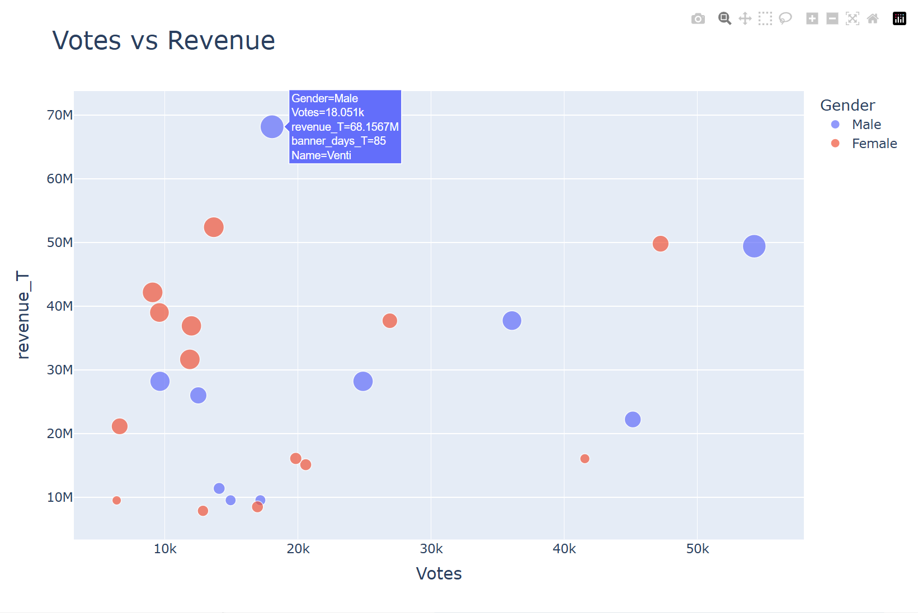

2.1.2 Factors Causing Divergence and Exceptions Between Popularity and Revenue
Despite the general alignment, statistical analysis yields a low $R^{2}$ value, indicating that vote counts cannot accurately predict revenue. The main drivers behind this mismatch include:
- Market Dynamics and Regional Spending Power (The Mondstadt Anomaly):
Mondstadt exhibits a notable pattern of low vote share paired with exceptionally high revenue share. This indicates that even if characters from this region do not lead in popularity, they attract a highly dedicated player base with strong spending power (high average spend per user).
- Monetization Efficiency Across Weapon Types and Gender Combinations:
  - Bows: Despite achieving only moderate overall vote popularity, male bow users hit the highest revenue ceiling. This reveals an exceptionally high monetization efficiency per fan.
  - Swords: Male sword users peak in popularity but yield only moderate revenue (high popularity fails to convert into high sales). Conversely, female sword users demonstrate substantial revenue potential despite receiving fewer votes.
  - Claymores: While accounting for the lowest overall share in both votes and revenue, their unique mechanics still capture a dedicated, niche paying audience.
- Interference from Hidden Drivers:
Outliers like Kaedehara Kazuha and Nahida demonstrate that low-popularity, high-revenue cases are strongly influenced by a character's meta-strength, marketing budget, release timing, and current gameplay environment. Players often spend heavily on a character due to high tactical value rather than pure aesthetic preference or popularity (voting).
- Limited Impact of Non-Critical Factors:
The analysis also reveals that while voice actors enhance the overall experience, their influence shows no significant correlation with votes or revenue, proving that voice cast is not a primary driver of commercial success.

2.1.3 Summary of Impact of Popularity on Revenue
While character popularity serves as a foundation for commercial success, live-service game operations cannot rely solely on superficial popularity to predict financial returns. Understanding market anomalies like Mondstadt, high-efficiency weapon-gender combinations, and hidden drivers like meta-strength is essential for formulating precise monetization and character development strategies.

2.2 Impact of Abilities on Daily Revenue
This section examines the causal relationship between a character's underlying design metrics—categorized into baseline combat statistics ("Stats") and functional mechanics ("Skills")—and their respective daily commercial revenue. A common market assumption is that superior attributes directly yield higher financial returns. However, in live-service gaming economies, numerical stats frequently depreciate due to ongoing version updates and power creep, whereas fundamental skill mechanics consistently retain their core value. To ensure a methodologically fair and objective analysis across the dataset, this report utilizes the data from each character's initial release banner to eliminate external macroeconomic distortions. Understanding these dynamics is essential for balancing product design and optimizing revenue generation strategies.

2.2.1 Definition
To rigorously evaluate commercial performance, the core variables are operationalized into two distinct categories of "Abilities." First, Stats represent quantitative, baseline combat attributes at Level 90: Health Points (HP) dictate maximum survival capacity; Attack (ATK) establishes baseline damage output; and Defense (DEF) reduces incoming damage. Second, Skills refer to qualitative functional mechanics, classified into Utility skills (enhancing open-world exploration), offensive skills (maximizing damage output), and survival skills (improving survivability). Finally, Daily Revenue is defined as the total revenue generated during a character's initial banner period divided by its total duration. Given the limited sample size ($N=23$ premium characters), preliminary statistical testing yielded $p$-values significantly exceeding the 0.05 threshold. Consequently, this dataset is insufficient for predictive modeling and is utilized strictly to analyze qualitative relationships and market phenomena.

2.2.2 Correlation between Stats and Revenue

To empirically evaluate the financial impact of character attributes, three separate scatter plots were constructed to analyze the relationships between baseline statistics—specifically 90lv ATK, 90lv HP, and 90lv DEF—and Daily Revenue. In each visual model, the vertical y-axis represents the Daily Revenue (in USD), while the horizontal x-axis measures the respective numerical values of each combat Stat. The individual data points plotted across the charts correspond to the 23 premium characters within the dataset, color-coded by gender (blue for male, red for female). Additionally, the linear regression lines accompanied by shaded confidence intervals illustrate the specific directional trends and correlation strengths for each demographic group.

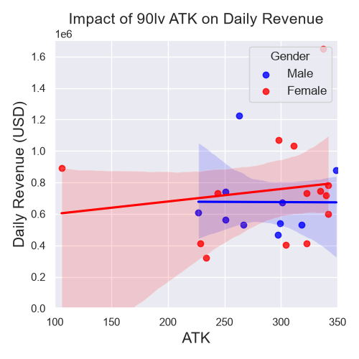

Empirical analysis indicates that base combat statistics ("Stats") do not serve as reliable financial drivers, debunking the conventional assumption that higher attributes generate superior market returns. For baseline damage output, the correlation between 90lv ATK and daily revenue is practically non-existent for male characters ($r=0$, $p=0.99$) and statistically negligible for female characters ($r=0.15$, $p=0.60$).

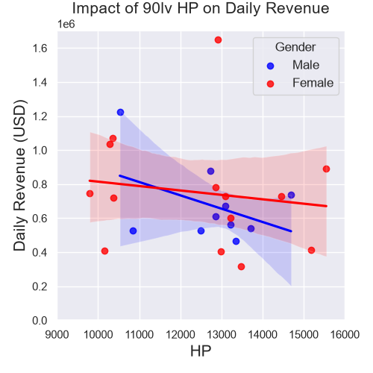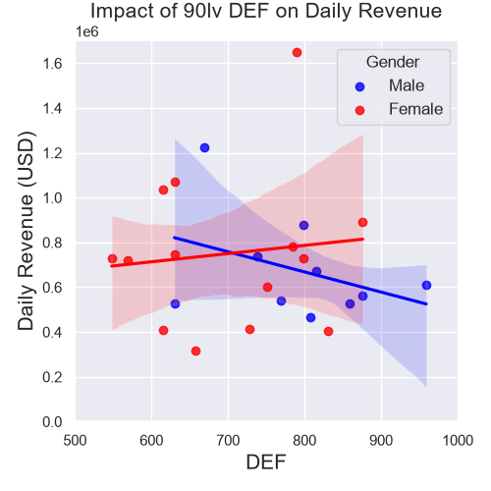
Similarly, defensive and survival attributes exhibit no positive financial contribution. Higher maximum survival capacity (HP) actually correlates negatively with daily revenue for both male ($r=-0.43$, $p=0.22$) and female characters ($r=-0.15$, $p=0.62$). A similar pattern emerges for damage reduction (DEF), where male characters show a negative correlation ($r=-0.38$, $p=0.27$) and female characters display a weak, insignificant positive correlation ($r=0.11$, $p=0.71$). With all $p$-values substantially exceeding the 0.05 threshold, these baseline stats fail to achieve statistical significance. This implies that consumer purchasing decisions in this live-service market are decoupled from raw character attributes, rendering numeric upgrades ineffective as primary revenue-driving value propositions.
Furthermore, this negative correlation underlines a distinct consumer behavioral pattern: characters designed with high survival attributes (HP and DEF) typically suffer from mediocre offensive output. In a gameplay environment focused on optimization, such defensive hyper-specialization results in low-efficiency combat, which significantly dampens the player experience by prolonging battles. Consequently, consumers demonstrate a much lower willingness to pay for these high-survival, low-efficiency combat characters, suppressing their overall banner revenue.

2.2.3 Revenue Distribution across Skill Types

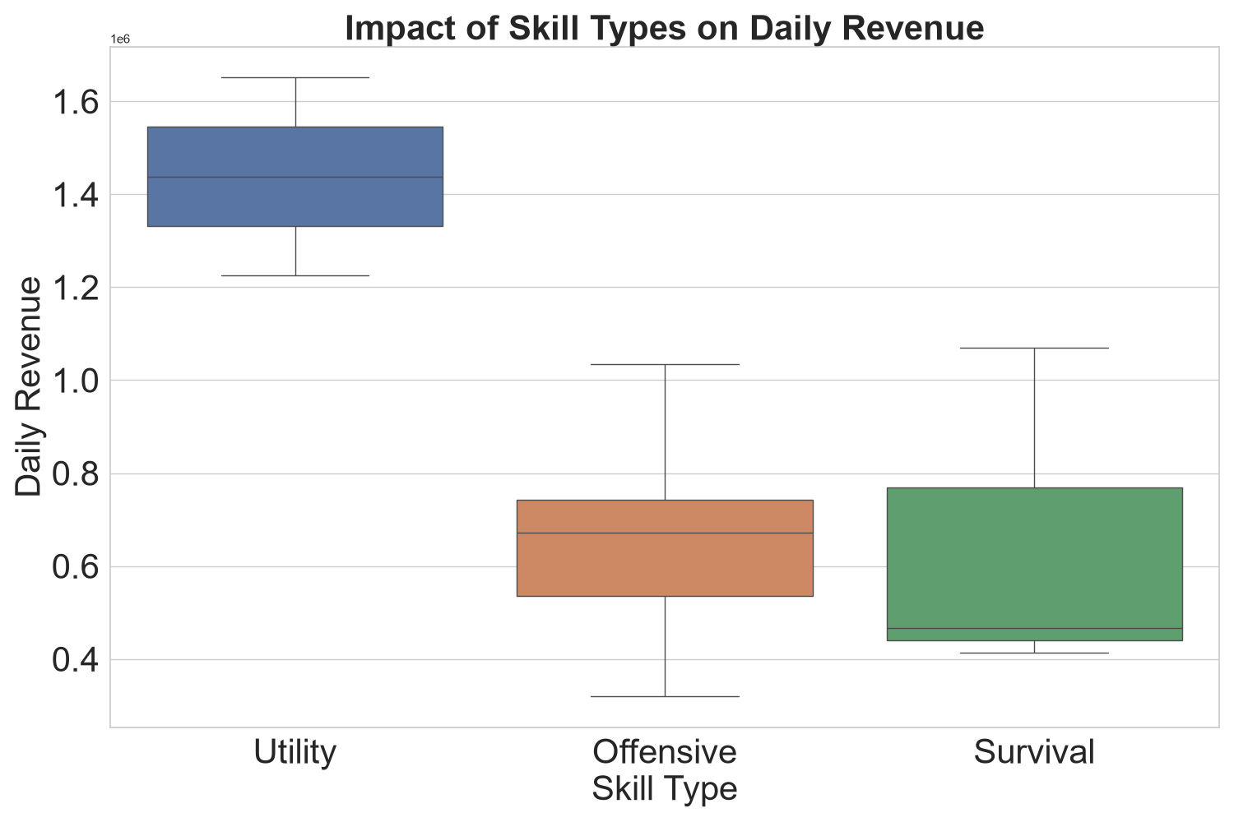


The boxplot analysis reveals that commercial performance varies significantly across different skill classifications, highlighting a distinct hierarchy in consumer valuation. Utility skills present a low-risk, high-reward commercial profile with low volatility; they maintain a premium high revenue baseline, featuring a median daily revenue of approximately $1.4M USD and a robust revenue floor of $1.2M USD. This segments' performance is epitomized by top sellers like Venti and Raiden Shogun, whose mechanics deliver unmatched in-game convenience and efficiency.



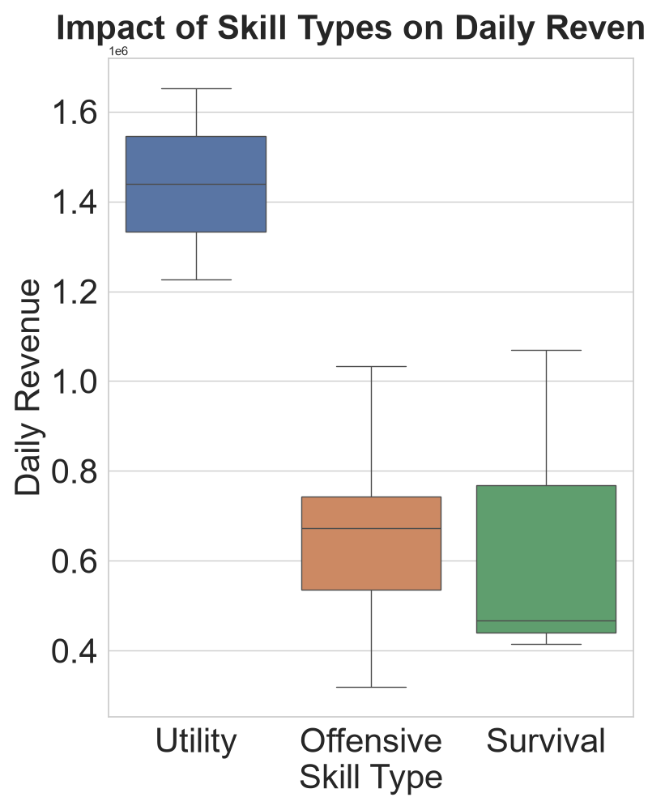

Conversely, Offensive and Survival skills deliver consistent but highly limited commercial returns. Because their value propositions are heavily pegged to numerical stats, these products carry an inherent devaluation risk from version updates, ultimately leading to poor long-term customer satisfaction. Interestingly, the data reveals two notable outliers: Klee and Nahida. Despite lacking traditional utility skills, both female characters surpassed the $1M USD daily revenue threshold. Belonging to the short-model type, these outliers empirically validate the findings in Section 2.1, proving that model-driven popularity operates as an independent and highly potent revenue catalyst.

2.2.4 Summary of Impact of Abilities on Daily Revenue
In summary, daily banner revenue is structurally decoupled from raw numerical stats, as consumers actively reject low-efficiency, high-survival attributes that prolong combat. Instead, financial returns are driven by functional utility skills that maximize in-game efficiency, alongside aesthetic factors like short-model popularity. Consequently, product design strategies should prioritize high-convenience mechanics over raw attribute scaling to optimize player satisfaction and sustainable revenue generation.

2.3 Revenue Analysis

2.3.1 Revenue timeline by Event Type
Firstly, this is a Revenue Timeline by Event Type line chart showing how revenue changes over time across different event categories. It starts from September 2020 to November 2022.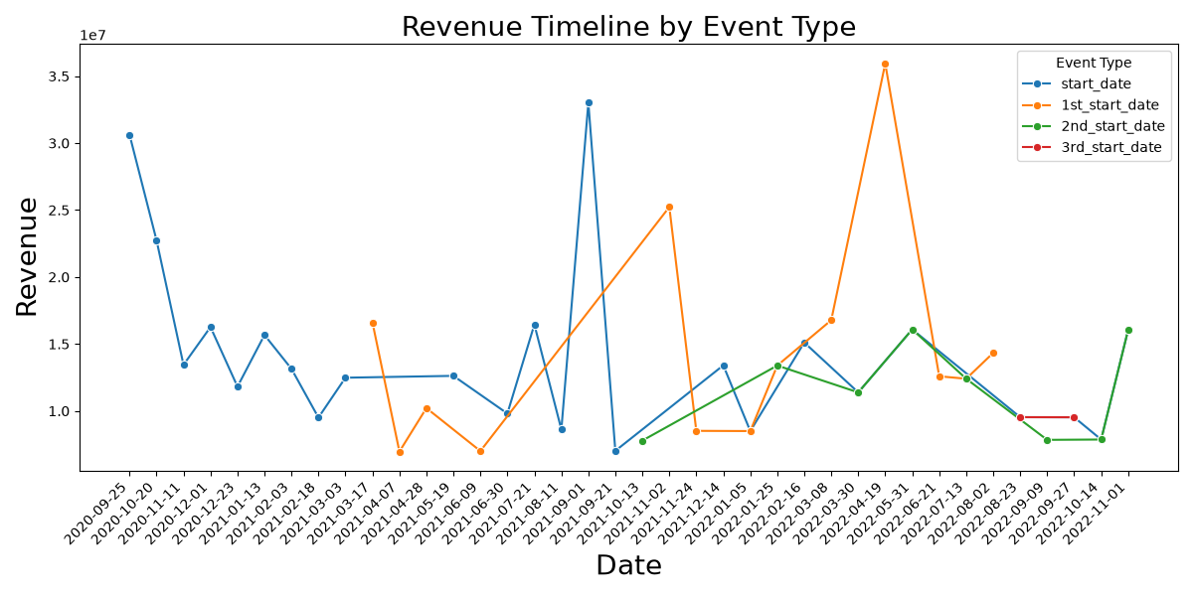

With the observations by the graph:
Blue Line (start_date): Most active during the early phase (late 2020) starting high at around 30 million, followed by fluctuating declines. It spikes significantly around September 2021, reaching nearly 33 million. Orange Line (1st_start_date): Appears in early 2021 and reaches the highest revenue peak on the entire chart (over 35 million) around mid-April 2022 (2022-04-19). Green & Red Lines: Introduced later in the timeline (late 2021 to 2022). Their revenue streams are relatively stable, mostly hovering between 10 million and 16 million.

2.3.2 All Characters Revenue
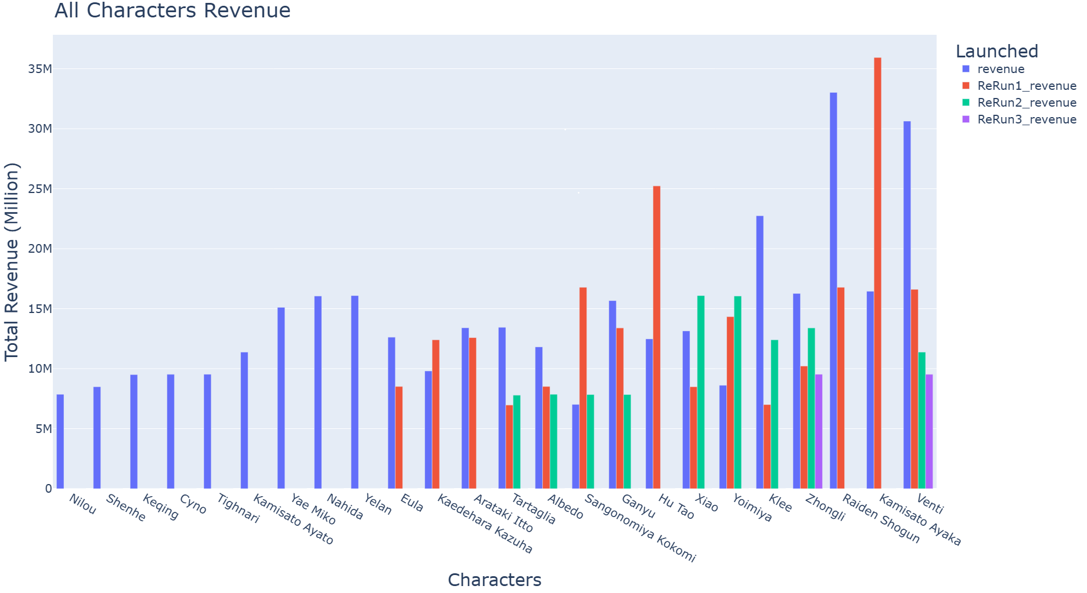Secondly, based on the data presented in the line bar chart, it generates character’ revenue for each sales. Raiden Shogun, Kamisato Ayaka, Venti and Hu Tao take the lead. Upon further analysis and a detailed comparison of the bar charts, it appears that Kamisato Ayaka's total revenue is either slightly higher than or very close to that of the Raiden Shogun.

2.3.3 All Characters Total Revenue
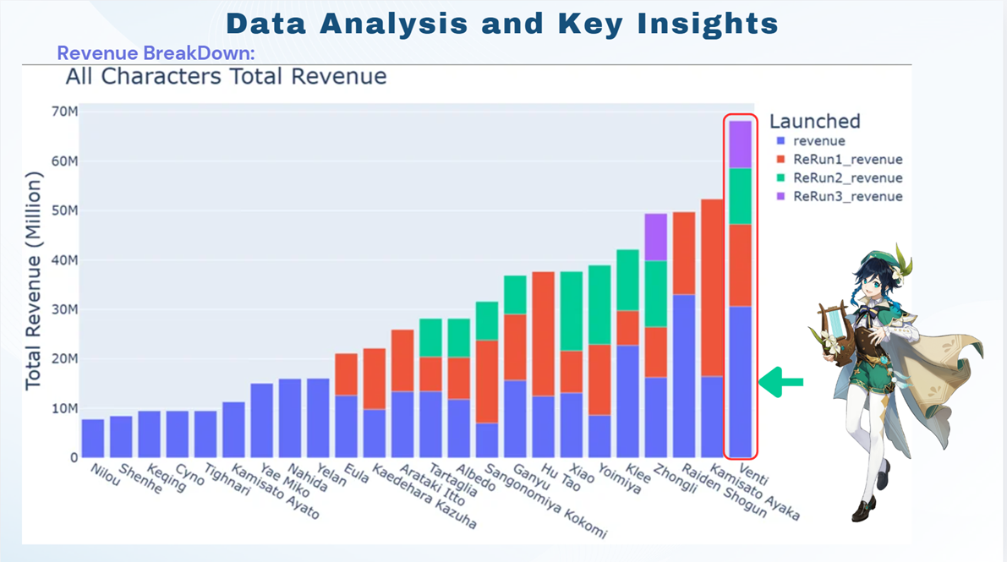
For the next stacked bar chart, it clearly shows Venti leads with the highest total lifetime revenue, exceeding $68 million. It is driven by the consistent vertical stacking from four separate banner appearances.
While Kamisato Ayaka achieved the highest revenue from a single banner block, Venti's long-term multi-rerun strategy solidifies his status as the overall market leader.

2.3.4 Key Performer Business Model Insights:
Venti cumulatively surpassed $68 million. It generated over $30 million at launch, followed by $16 million in first rerun, $11 million in second rerun, and $10 million in third rerun. The total sales revenue, Character Venti reached the highest revenue.
Kamisato Ayaka cumulatively earned around $52.5 million. The primary supported by a significant long-tail revenue effect during her first rerun raised to $36 million during her first rerun due to an extended banner window caused by a real-world development delay. that extended her banner's availability, demonstrating how market vacuum periods can significantly elevate a product's revenue potential.
Raiden Shogun cumulatively nearing $50 million. it hits a peak baseline of $33 million at launch and $17 million in her first rerun, proving high monetization efficiency during peak exposure. Raiden Shogun achieving a top-three position without any Rerun 2 or 3 blocks indicates that top-tier intellectual properties possess remarkable monetization efficiency during peak exposure periods.
2.3.5 Heatmap Analysis
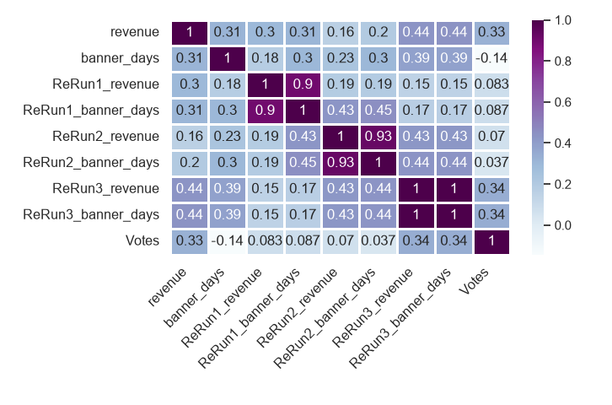In this heatmap, the correlation between the two has shifted to 0.3 (positive correlation) "Votes" show highly drastic changes in its values. This indicates a major shift in the underlying data structure of the heatmap. A positively correlated with initial revenue (0.33) and third rerun revenue (0.34). This confirms that community hype (high vote counts) directly translates into actual consumer spending. This is especially true for initial releases and older characters undergoing multiple reruns, where high popularity serves as a reliable guarantee for sales.
Meanwhile, the correlation between initial release revenue and the third rerun revenue has also reached 0.44. There is a positive correlation between "Banner Days" and "Subsequent Rerun Revenue" (0.31 and 0.44). It reveals a "the strong stay strong" pattern. In other words, the more popular a character is and the better they sell during their initial release, the more they can consistently generate revenue and maintain high popularity during their first, second, and even third reruns.
2.3.6 Summary of Impact on Revenue
Long-Term Stacking Wins: Multi-rerun longevity creates the highest revenue ceiling. Venti leads the market at greater than 68 million by stacking four steady revenue phases over time.
Peak Velocity is Efficient: Top-tier assets maximize revenue in fewer windows. Raiden Shogun neared 50 million in just two banners, proving massive monetization efficiency during peak exposure.
Vacuums Amplify Revenue: Extended availability during market gaps drives massive spending. Kamisato Ayaka’s at 36 million. Rerun 1 proves that operational delays can be successfully converted into major financial windfalls.
Data Feeds the Calendar: Early success creates a virtuous operational loop. Strong initial performance gives developers the data confidence to award characters longer, premium slots in later rerun cycles.

3. Conclusion & Suggestion
3. Conclusion
The financial sustainability of live-service enterprises hinges upon dynamic operational flexibility and understanding consumer purchasing behavior. Empirical data demonstrates that while a positive correlation exists between product popularity and revenue, popularity alone does not dictate financial success. Notably, low-popularity assets can still generate peak returns when backed by robust strategic positioning and sound operational timing.

Furthermore, contemporary consumer trends reveal a distinct decoupling between revenue and raw numerical metrics. Players actively reject low-efficiency products and instead pay a substantial utility premium for high-convenience functional mechanics. To capitalize on these behavioral patterns, organizations must abandon rigid release schedules. They should leverage multi-rerun longevity to stack steady income, utilize top-tier assets to maximize returns during launch windows, and turn operational delays into profitable opportunities by exploiting market gaps to drive massive spending. Implementing these pillars will guarantee long-term market dominance and maximize shareholder value.

Suggestion
- Tiered Value Propositions:
Segment the consumer base by deploying hyper-premium vanity options for price-insensitive cohorts, while utilizing high-utility subscriptions for value-driven segments.
- Agile Asset Repositories:
Maintain a pre-optimized "Buffer Portfolio" of historical product re-releases to instantly offset production delays and convert downtime into high-velocity revenue..
- Predictive Re-release Analytics:
Integrate Churn Models and Market Saturation Indices to optimize rerun scheduling, thereby preventing consumer fatigue and maximizing marginal lifecycle utility.
- Pre-Launch Ecosystem Audits:
Establish formal user-testing frameworks to assess product mechanical efficiency before commercial launch, safeguarding marketing capital from consumer backlash.

4. Appendix
4. Appendix

Data Sources:

Matea, Genshin Impact Character Popularity Dataset, Kaggle, from https://www.kaggle.com/datasets/matear/genshin-impact-character-popularity-dataset

Ng. T. S., Genshin Impact Characters Dataset, Kaggle, from https://www.kaggle.com/datasets/ngtengsuan/genshin-impact-characters-dataset

Yo. S., Genshin Impact Character Revenue, Kaggle, from https://www.kaggle.com/datasets/saladyong/genshin-impact-banner-revenue

Additional Information:

Genshin Impact Wiki, Fandom, from https://genshin-impact.fandom.com/wiki/Genshin_Impact_Wiki

Genshin Impact Official, Reddit, from https://www.reddit.com/r/Genshin_Impact/hot/

